Supporting Information

Observation of stabilized negative capacitance effect in hafnium-based ferroic films

*Leilei Qiao1, Ruiting Zhao2, Cheng Song1*, Yongjian Zhou1, Qian Wang1, Tian-Ling Ren2, Feng Pan1\**

1 Key Laboratory of Advanced Materials (MOE), School of Materials Science and Engineering, Tsinghua University, Beijing 100084, China   
E-mail: songcheng@mail.tsinghua.edu.cn; panf@mail.tsinghua.edu.cn

2Institute of Microelectronics & Beijing National Research Center for Information Science and Technology (BNRist), Tsinghua University, Beijing, 100084, China

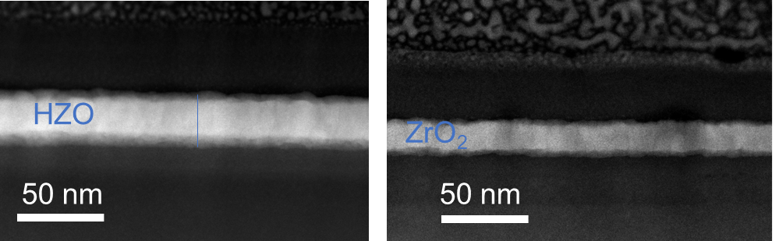

**Figure S1.** Cross-sectional transmission electron microscope image of HZO and ZrO2 films. The thickness of HZO and ZrO2 layer is 34 and 17.8 nm, respectively.



**Figure S2.** Grazing incidence X-ray diffraction (GIXRD) results of HZO (a) and ZrO2 films (b).



**Figure S3**.Ferroelectric hysteresis loop of HZO film.



**Figure S4.** Leakage current of HZO (a) and ZrO2 films (b).

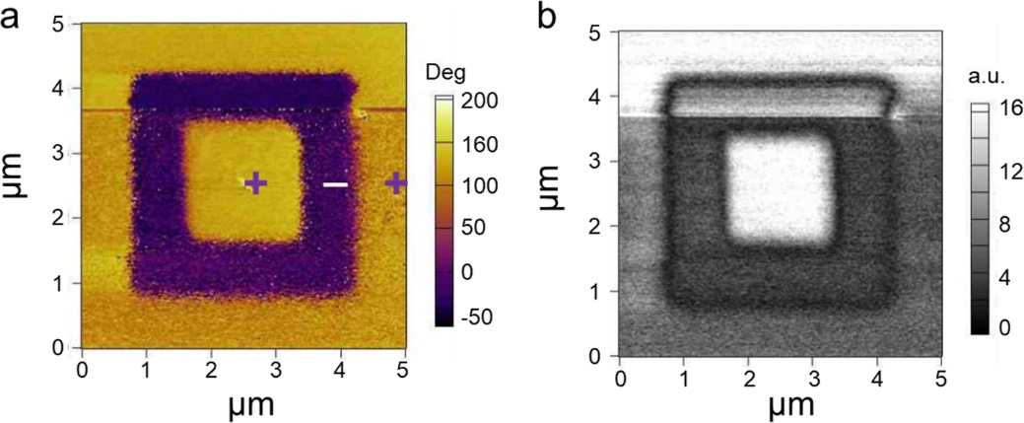

**Figure S5**. PFM out-of-plane (a) phase and (b) amplitude image recoded after writing an area of 3×3 μm2 with –5 V and then central 1.5×1.5 μm2 square with +5 V using a biased conductive tip.



**Figure S6.** Single-domain structure in certain region of HZO film. (a) Single-domain structure in certain region at the origin state. (b) PFM out-of-plane phase image in the central region of (a). A –6 V voltage is applied at the central 1.5×1.5 μm2 square. A 6 V voltage is applied at the edge region. (c) Local PFM hysteresis amplitude loop. (d) Local PFM hysteresis phase loop.



**Figure S7**. Transient NC effect of ferroelectric HZO capacitors. (a) Schematic measurement set-up. The HZO capacitor is connected in series with an external resistor of 3 kΩ. (b) Source voltage *V*s and the voltage across the antiferroelectric HZO capacitor *V*FE as a function of time *t*. (c) Source voltage *V*s and corresponding current *I* through the circuit. (d) Charge *Q* response. (e) Calculated *P*–*E* loop with different series resistors for HZO capacitor.



**Figure S8**. (a) Current and (b) charge response of ferroelectric capacitor when no resistor is connected in series.

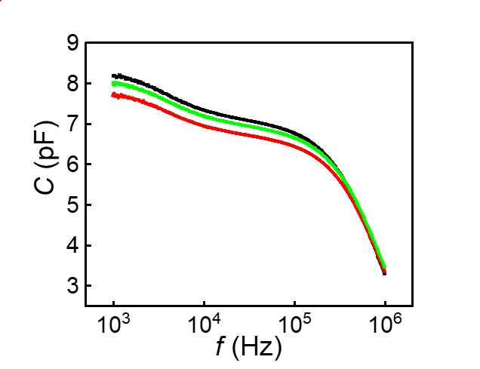

**Figure S9.** Frequency dependent capacitance response versus voltage for different Al2O3 capacitors with the same thickness of 10 nm.



**Figure S10.** Leakage current of Al2O3 films with 10 nm (a, b), 20 nm (c, d) and 30 nm (e, f) thickness.



**Figure S11**. (a) XRD spectrum of the ZrO2 film. The ZrO2 film shows (110) out-of-plane orientation in tetragonal crystal structure, marked by the orange rhombus. The blue stars and black dots mark the diffraction peaks of LAO substrate and LSMO bottom electrode, respectively. (b) Capacitance and voltage response of the ZrO2 capacitor with double-butterfly shape, displaying a classic antiferroelectric property.



**Figure S12**. (a) Current and (b) charge response of antiferroelectric capacitor under 9 V *V*s amplitude when no resistor is connected in series. (c) Current and (d) charge response or antiferroelectric capacitor under –9 V *V*s amplitude when no resistor is connected in series.



**Figure S13**. (a) Source voltage *V*s with 9 V amplitude and corresponding current *I* through the circuit after connecting a 3 kΩ resistor in series. (b) Source voltage *V*s and the voltage across the antiferroelectric ZrO2 capacitor *V*AFE under 9 V *V*s. (c) Charge response 9 V *V*s. (d) Source voltage *V*s with –9 V amplitude and corresponding current *I* through the circuit. (e) Source voltage *V*s and the voltage across the antiferroelectric ZrO2 capacitor *V*AFE under –9 V *V*s. (f) Charge *Q* response under –9 V *V*s. (g) Calculated *P*–*E* loop with different series resistors for ZrO2 capacitor.