Supporting Information

Towards an enhanced understanding of the particle size effect on conversion/alloying lithium-ion anodes

Jakob Asenbauer^{1,2}, Dominik Horny³, Mayokun Olutogun^{1,2}, Katrin Schulz^{3,4,}*, Dominic Bresser^{1,2,}*

¹ Helmholtz Institute Ulm (HIU), 89081 Ulm, Germany
² Karlsruhe Institute of Technology (KIT), 76021 Karlsruhe, Germany
³ Institute for Applied Materials (IAM), Karlsruhe Institute of Technology (KIT), 76131 Karlsruhe, Germany
⁴ Karlsruhe University of Applied Sciences, 76133, Karlsruhe, Germany

Keywords: particle size; conversion; alloying; anode; lithium-ion battery

*Corresponding authors: dominic.bresser@kit.edu ; Katrin.Schulz@h-ka.de
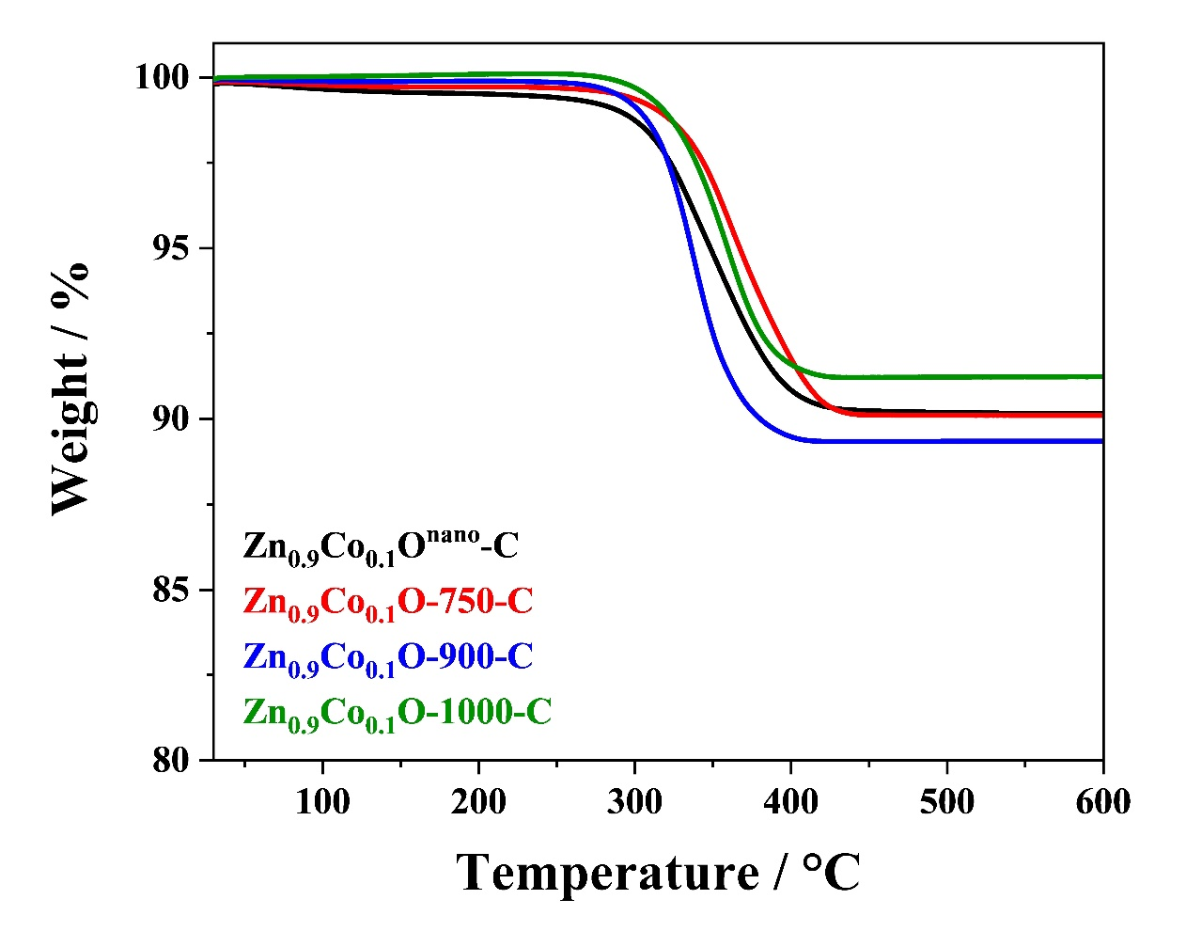
Figure S1. Thermogravimetric analysis (TGA) of the carbon-coated Zn_{0.9}Co_{0.1}O samples under oxygen atmosphere.
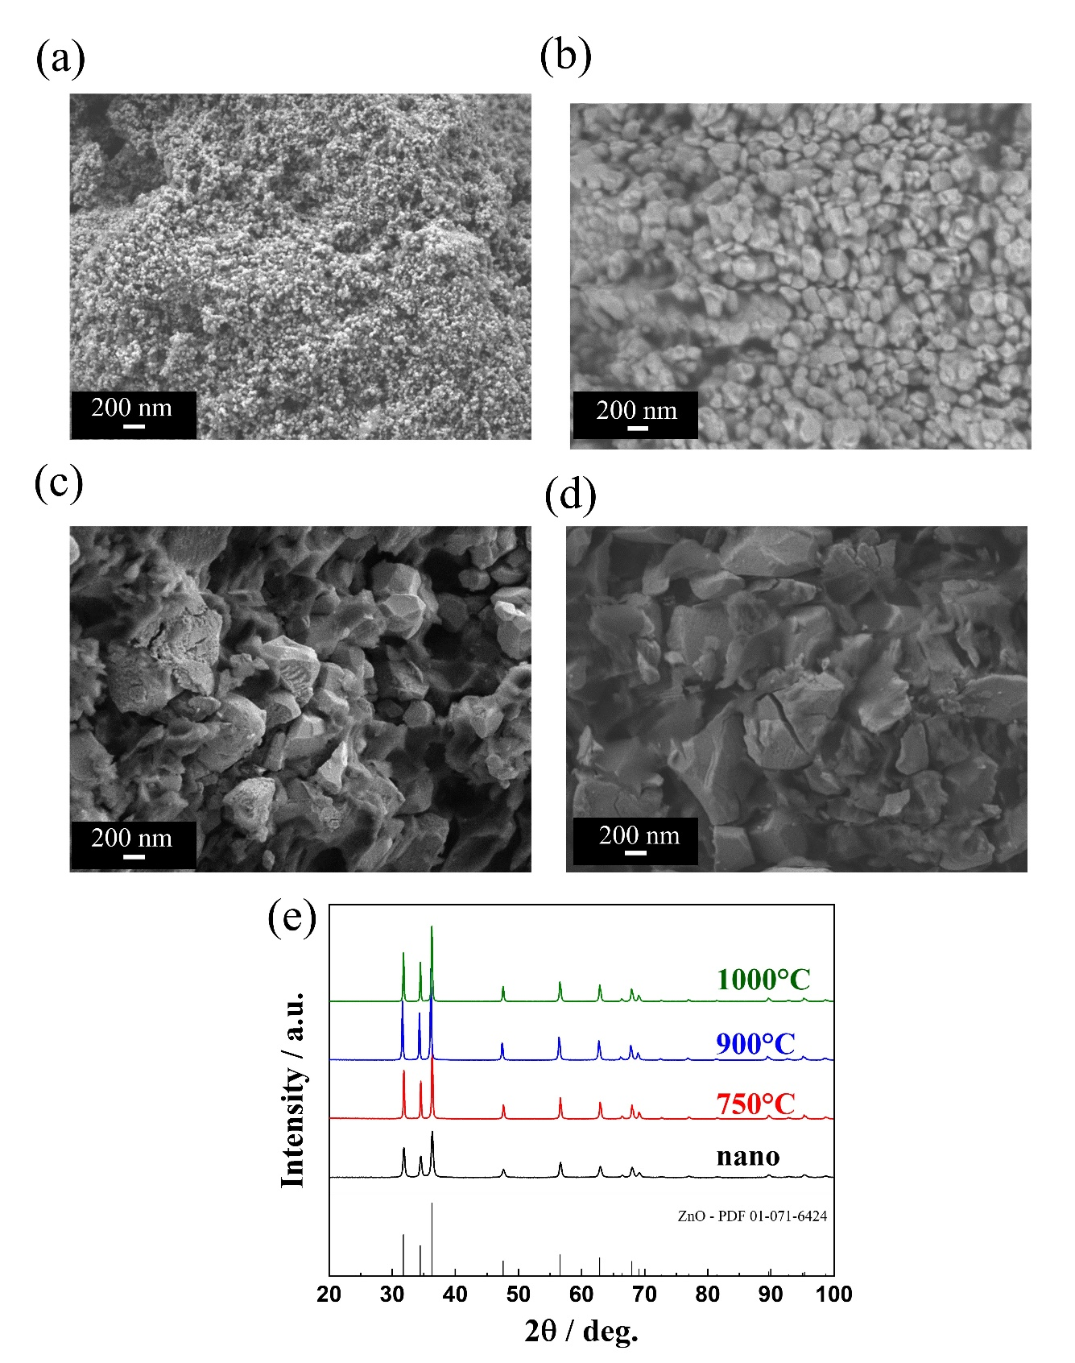
Figure S2. (a-d) SEM micrographs of (a) Zn_{0.9}Co_{0.1}O^{nano}-C, (b) Zn_{0.9}Co_{0.1}O-750-C, (c) Zn_{0.9}Co_{0.1}O-900-C, and (d) Zn_{0.9}Co_{0.1}O-1000-C. (e) Comparison of the XRD patterns recorded for the four samples with the PDF reference 01-071-6424 for wurtzite ZnO given in the bottom.

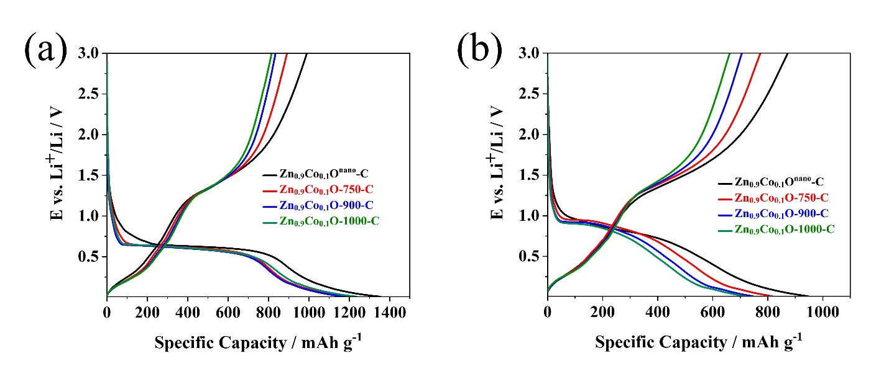
Figure S3. Electrochemical characterization of carbon-coated Zn_{0.9}C_{0.1}O with different particle sizes in half-cells (cut-off voltages: 0.01 and 3.0 V): (a) The dis-/charge profiles for the first cycle at C/20 (50 mA g⁻¹) with Zn_{0.9}Co_{0.1}O^{nano}-C in black, Zn_{0.9}Co_{0.1}O-750-C in red, Zn_{0.9}Co_{0.1}O-900-C in blue, and Zn_{0.9}Co_{0.1}O-1000-C in green; (b) the dis-/charge profiles for the second cycle at C/5 (200 mA g⁻¹);
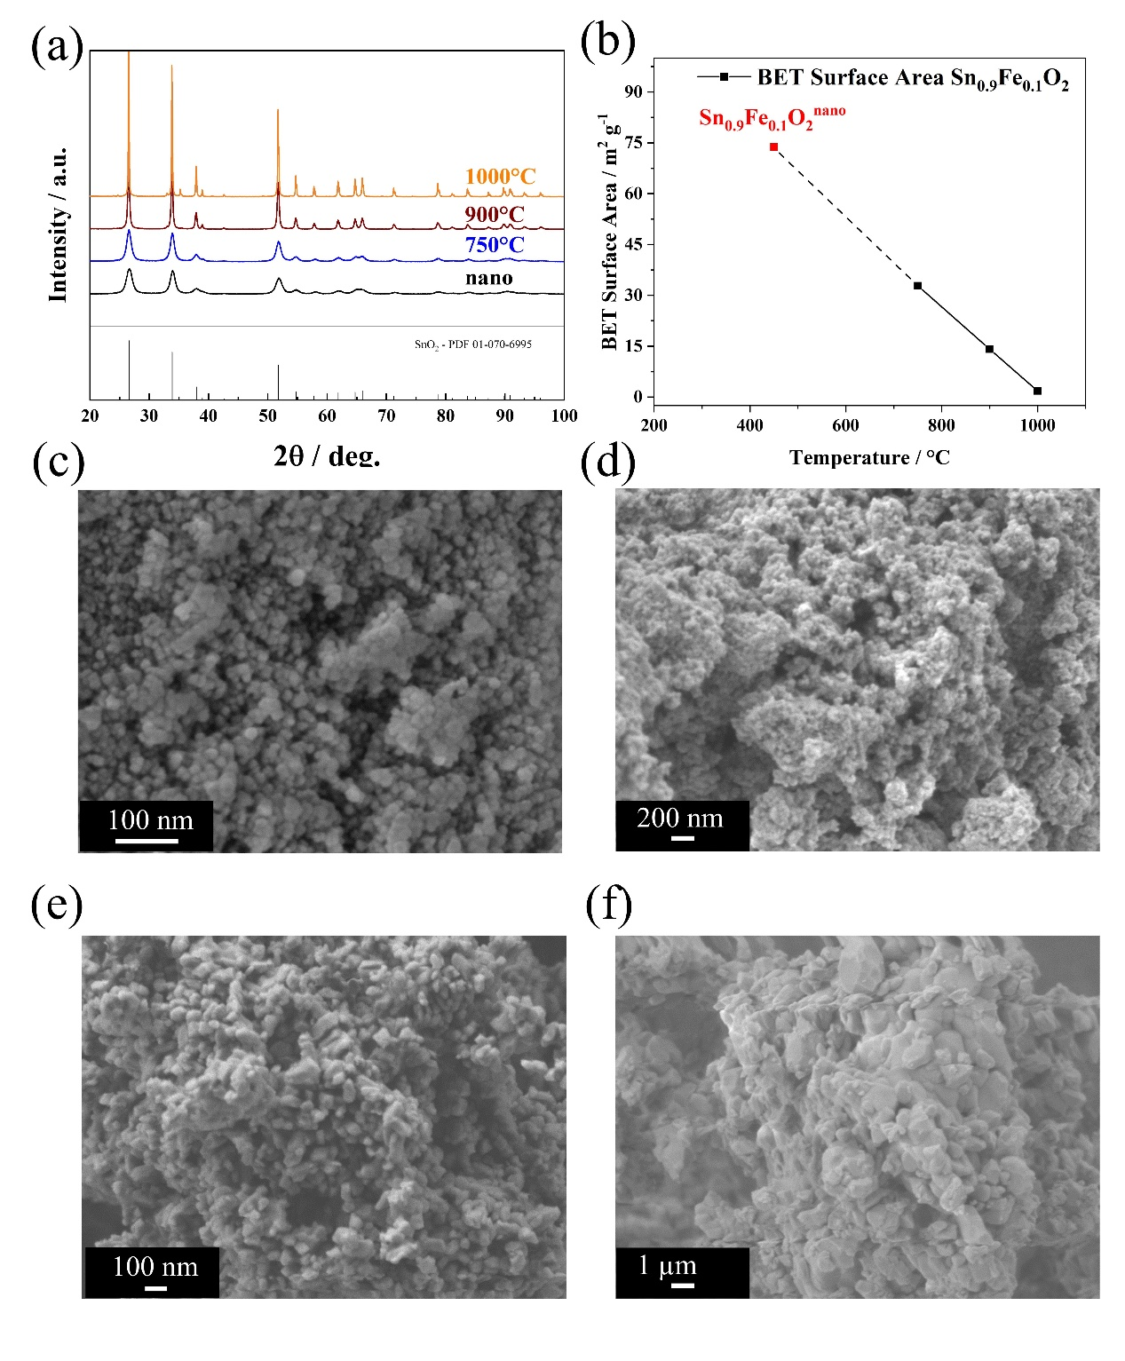
Figure S4. (a) Comparison of the XRD patterns for Sn_{0.9}Fe_{0.1}O₂^{nano} (in black), Sn_{0.9}Fe_{0.1}O₂-750 (in blue), Sn_{0.9}Fe_{0.1}O₂-900 (in brown), and Sn_{0.9}Fe_{0.1}O₂-1000 (in orange) with the PDF reference 01-070-6995 for cassiterite SnO₂ given in the bottom. (b) Comparison of the BET specific surface area for these samples. (c-f) SEM micrographs of (c) Sn_{0.9}Fe_{0.1}O₂^{nano}, (d) Sn_{0.9}Fe_{0.1}O₂-750, (e) Sn_{0.9}Fe_{0.1}O₂-900, and (f) Sn_{0.9}Fe_{0.1}O₂-1000.

