Supporting Information

Ultrathin SrTiO₃-based oxide memristor with both drift and diffusive dynamics as versatile synaptic emulators for neuromorphic computing
Fang Nie,^{1,2,#} Jie Wang,^{3,4,#} Hong Fang,^{3,4,#} Shuanger Ma,¹ Feiyang Wu,¹ Wenbo Zhao,¹ Shizhan Wei,¹ Yuling Wang,⁵ Le Zhao,^{2,}* Shishen Yan,^{1,4} Chen Ge,^{6,}* and Limei Zheng,^{1,}*

¹ School of Physics, State Key Laboratory of Crystal Materials, Shandong University, Jinan 250100, China
² School of Information and Automation Engineering, Qilu University of Technology (Shandong Academy of Science), Jinan 250353, China
³ Functional Materials and Acousto-Optic Instruments Institute, School of Instrumentation Science and Engineering, Harbin Institute of Technology, Harbin 150080, China
⁴ Spintronics Institute, School of Physics and Technology, University of Jinan, Jinan 250022, China
⁵ Heilongjiang Provincial Key Laboratory of Oilfield Applied Chemistry and Technology, School of Mechatronic Engineering, Daqing Normal University, Daqing 163712, China
⁶ Beijing National Laboratory for Condensed Matter Physics, Institute of Physics, Chinese Academy of Sciences, Beijing 100190, China

#These authors contributed equally: Fang Nie, Jie Wang, Hong Fang.
*Corresponding authors: dianxinzl@qlu.edu.cn (Le Zhao); gechen@iphy.ac.cn (Chen Ge); zhenglm@sdu.edu.cn (Limei Zheng)
Note 1. Thermionic emission (TE) model
Charge carriers have the possibility to overcome the barrier by thermal excitation when temperature is above zero, which is called thermionic emission (TE)[1]. For the HRS, the transport is dominated by the Schottky barriers, where the current (I_{TE}) increases exponentially with voltage in forward bias. The thermionic emission mechanism is thus adopted to describe the HRS current. For the thermionic emission (TE) currents, under forward bias (V > 3k_{B}T/q), the current across the Schottky barrier is given by[2]
$I_{TE}=SA^{*}T^{2}θ_{n}exp(-\frac{Φ_{B}}{k_{B}T})exp(\frac{qV}{ηk_{B}T})$ (S1)
Where S is the electrode area, A* is the standard Richardson constant, T is the absolute temperature, θ_{n} is the transmission coefficient for tunneling across the interfacial layer, Φ_{B} is the Schottky barrier height, k_{B} is the Boltzmann’s constant and η is the ideality factor. In the calculations, A*=156 A cm⁻² K⁻². Through fitting the I-V curve at HRS, the calculated Schottky barrier height is about 0.505 eV.
Note 2. Direct tunneling (DT) model and Fowler-Nordheim tunneling (FNT) model
At LRS, direct tunneling (DT) is conspicuous at a low voltage and Fowler-Nordheim tunneling (FNT) dominates at a high voltage[3]. Essentially, direct tunneling currents and FN tunneling currents have the same origin, both being tunneled through the potential barrier by carriers with energy below the barrier height to the other side of the barrier. The main difference between them is the difference in the pressure drop across the oxide layer when tunneling occurs[4]. Direct tunneling is a quantum mechanical tunneling process with lower energy carriers, and it is also an elastic transport process close to equilibrium. The low-voltage part of the nonlinear LRS I-V curves can be well fitted to the direct tunneling (DT) model based on a trapezoidal barrier. The DT current I_{DC} through a trapezoidal barrier can be described as[5]
$I_{DC}=-S\frac{4em^{*}}{9π^{2}ℏ^{3}}\frac{exp\left\{α(V)[{(Φ_{2}-\frac{eV}{2})}^{\frac{3}{2}}-{(Φ_{1}+\frac{eV}{2})}^{\frac{3}{2}}]\right\}}{α^{2}{{[(Φ_{2}-\frac{eV}{2})}^{\frac{1}{2}}-{(Φ_{1}+\frac{eV}{2})}^{\frac{1}{2}}]}^{2}}×sinh\left\{\frac{3}{2}α(V)[{(Φ_{2}-\frac{eV}{2})}^{\frac{1}{2}}-{(Φ_{1}+\frac{eV}{2})}^{\frac{1}{2}}]\frac{eV}{2}\right\}$ (S2)
Where $α(V)=\frac{4d{(2m^{*})}^{\frac{1}{2}}}{3ℏ(Φ_{1}+eV-Φ_{2})}$, Φ₁ and Φ₂ are the barrier height at Cr/STO and STO/NSTO interface, respectively. S is the electrode area, m* is the effective electron mass, ħ is the reduced Planck constant and d is the STO barrier width of about 4 nm. Here, Φ₁ and Φ₂ are used as fit parameters to describe the direct tunnelling through a trapezoidal potential barrier. The calculated Φ₁ and Φ₂ are 0.36 eV and 0.47 eV for STO.
FN tunneling is a field-induced electron tunneling process. When the applied voltage exceeds the interfacial barrier height, part of the energy barrier profile will lie beneath the Fermi energy level of the electrode, consequently, the effective tunneling barrier become triangular-shaped potential barrier[6]. Fowler-Nordheim tunneling (FNT) is tunneling across a triangular-shaped potential barrier, which is formed by applying an electrical field E to a rectangular or trapezoidal barrier. FNT is basically the same physical phenomena as direct tunneling, but in a different voltage regime, i.e., the high-voltage regime. The tunneling current is given by[7]:
$I_{FNT}=S\frac{e^{3}}{8πhΦ_{i}}{(\frac{V}{d})}^{2}exp[-\frac{8π\sqrt{2m^{*}}dΦ_{i}^{\frac{3}{2}}}{3heV}]$ (S3)
where Φ_{i} is the height of trapezoidal barrier. In our experiment, we estimate that the threshold voltages for transition from DT to FNT are -0.1 V and +0.1 V, respectively. According to the fitting results of the FNT model, Φ_{i} was found to be 0.071 eV.

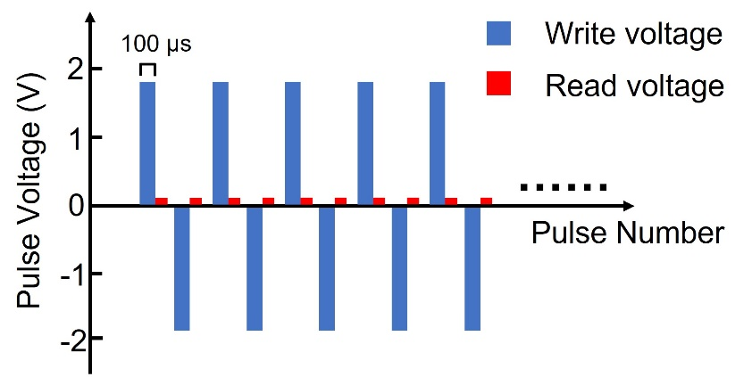
Figure S1 Schematic diagram of the voltage pulse sequence for the endurance test in Figure 1g.

References
- Yang S T et al 2022 High-performance neuromorphic computing based on ferroelectric synapses with excellent conductance linearity and symmetry Adv. Funct. Mater. 32 2202366
- Mikheev E, Hoskins B D, Strukov D B and Stemmer S 2014 Resistive switching and its suppression in Pt/Nb:SrTiO₃ junctions Nat. Commun. 5 3990
- Li J K, Ge C, Lu H T, Guo H Z, Guo E J, He M, Wang C, Yang G Z and Jin K J 2019 Energy-efficient artificial synapses based on oxide tunnel junctions ACS Appl. Mater. Interfaces 11 43473-43479
- Gruverman A et al 2009 Tunneling electroresistance effect in ferroelectric tunnel junctions at the nanoscale Nano Lett. 9 3539-3543
- Pantel D and Alexe M 2010 Electroresistance effects in ferroelectric tunnel barriers Phys. Rev. B 82 134105
- Yang Y H et al 2020 The role of ferroelectric polarization in resistive memory properties of metal/insulator/semiconductor tunnel junctions: a comparative study ACS Appl. Mater. Interfaces 12 32935-32942
- Li J K, Li N, Ge C, Huang H Y, Sun Y W, Gao P, He M, Wang C, Yang G Z and Jin K J 2019 Giant electroresistance in ferroionic tunnel junctions iScience 16 368-377

