**Supporting Information**

**A self-assembled nanoflower-like Ni5P4@NiSe2 heterostructure with hierarchical pores triggering high-efficiency electrocatalysis for Li-O2 batteries**

Xue Han1, Yanjie Liang1, Lanling Zhao2, Jun Wang 1,*, Qing Xia1, Deyuan Li1, Yao Liu1,*, Zhaorui Zhou1, Yuxin Long1, Yebing Li1, Yiming Zhang1, Shulei Chou3,*

1 Key Laboratory for Liquid-Solid Structural Evolution and Processing of Materials (Ministry of Education), Shandong University, Jinan 250061, China

E-mail: [jw707@sdu.edu.cn](mailto:jw707@sdu.edu.cn); liuyao@sdu.edu.cn

2School of Physics, Shandong University, Jinan 250061, China

3Institute for Carbon Neutralization, College of Chemistry and Materials Engineering

Wenzhou University, Wenzhou 325035, China

E-mail: chou@wzu.edu.cn

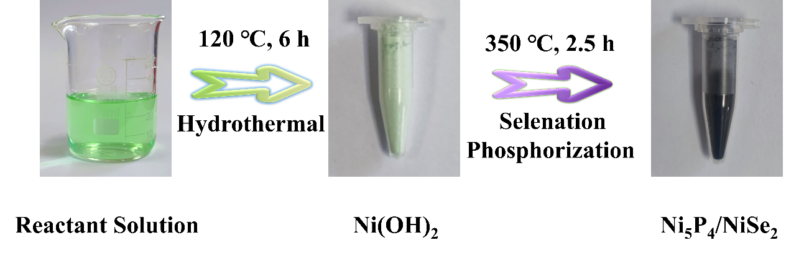

**Figure S1.** Fabrication photograph of Ni5P4@NiSe2heterostructure.



**Figure S2.** XRD pattern of Ni(OH)2 precursor.

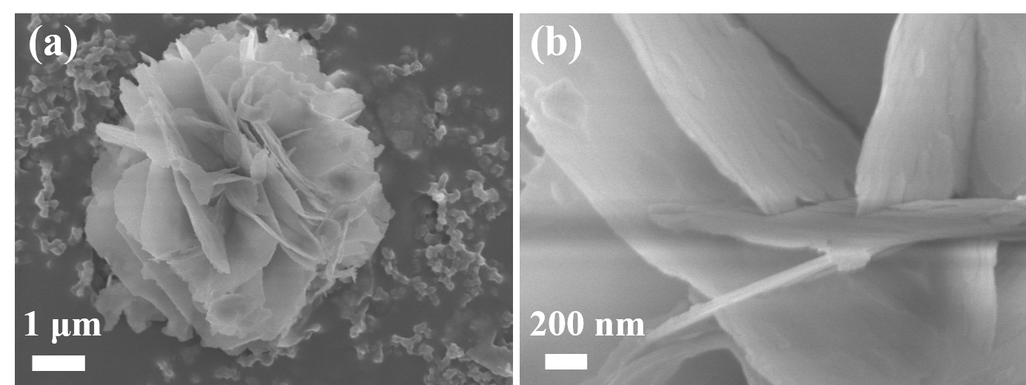

**Figure S3.** SEM images of Ni(OH)2 precursor.

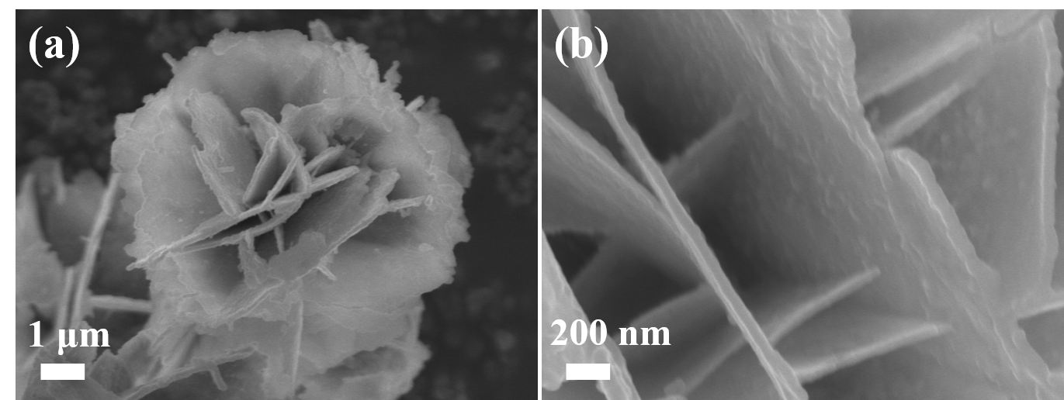

**Figure S4.** SEM images of Ni5P4 sample.

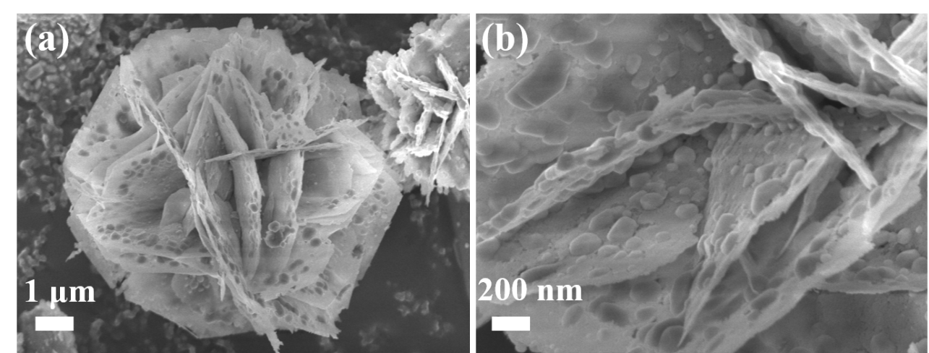

**Figure S5.** SEM images of NiSe2 sample.



**Figure S6.** The atomicratios of Ni5P4 and NiSe2 by XPS, EDS and ICP testing.

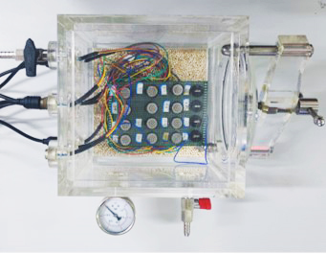

**Figure S7.** The battery testing box purchased from NJZH (Shenzhen) Scientific Ltd.



**Figure S8.** Initial discharge/charge plots of carbon paper.



**Figure S9.** Initial discharge/charge profiles of KB cathodes at different current densities.

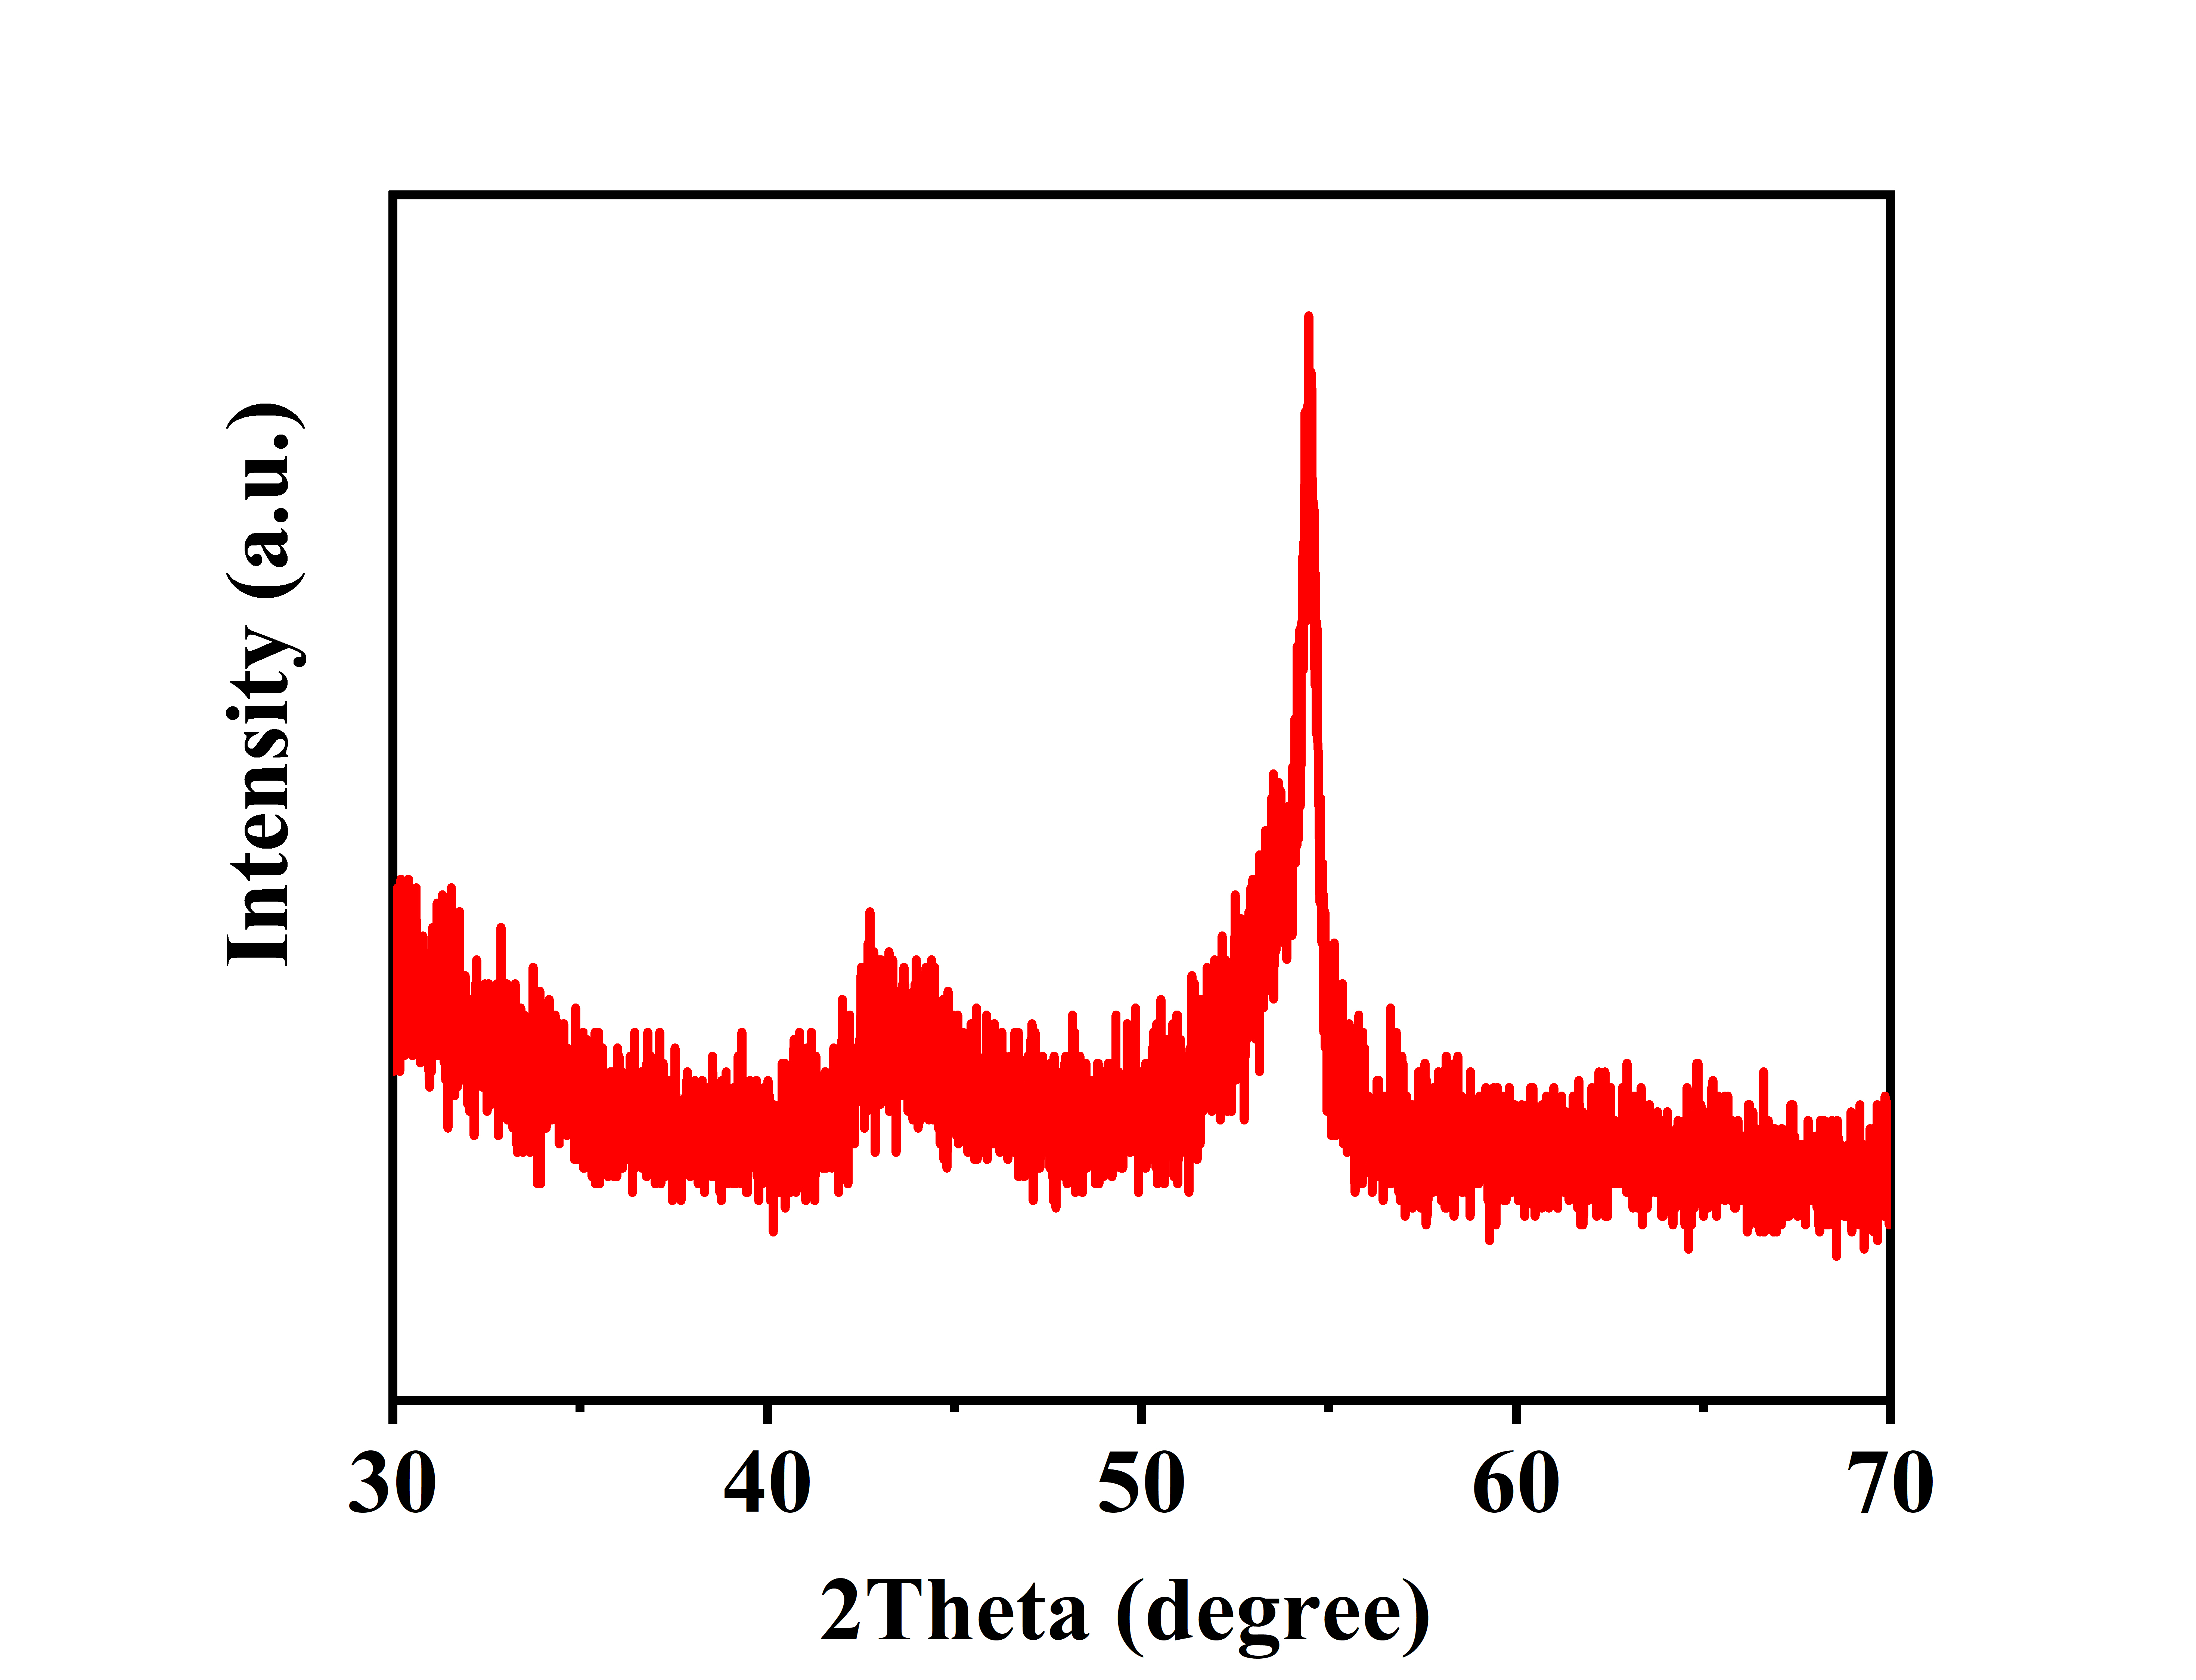

**Figure S10.** XRD pattern of pure carbon paper.

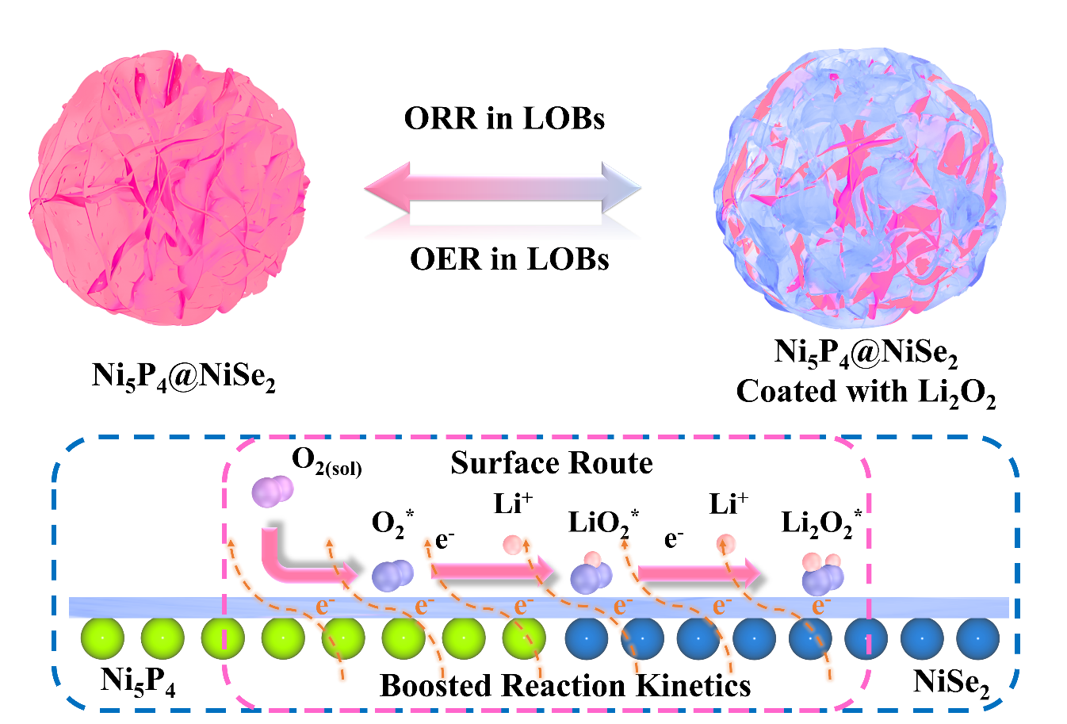

**Figure S11.** The Li2O2 formation and decomposition mechanism on Ni5P4@NiSe2 cathode.

**Table S1.** Electrocatalytic activity comparison of Ni5P4/NiSe2 cathodes with those of the recently reported similar cathodes.

|  |  |  |  |  |
| --- | --- | --- | --- | --- |
| Catalysts | Morphology | Discharge  Capacity  mA g-1/mA g-1 | Cycle number  (cycles/cutoff  Capacity) | Ref. |
| FeSe | Hollow spheroids | 14273/500 | 130/1000 | 1 |
| Ni2P/Ni12P5@NF | honeycomb-like | 13254.1/500 | 125/1000 | 2 |
| NiSe2@NiO | hierarchical | 11512/500 | 90/1000 | 3 |
| Ni12P5/RuO2/C | nanoparticles | 4296/200 | 56/500 | 4 |
| Ni2P | nanoparticles | 4104.4/200 | 70/500 | 5 |
| Co-Ni2P | 3D umbrella-like | 9331/100 | 147/1000 | 6 |
| **Ni5P4@NiSe2** | **Nanoflower-like** | **19090/100** | **202/600** | **This work** |

[1] Yoo H, Lee G H and Kim D W 2021 J. *Alloys Compd.* **856** 158269

[2] Ran Z Q, Shu C Z, Hou Z Q, Zhang W B, Yan Y, He M and Long J P 2021 *Chem. Eng. J.* **413** 127404

[3] Wen X J, Ran Z Q, Zheng R X, Du D Y, Zhao C, Li R J, Xu H Y, Zeng T and Shu C Z 2022 *J. Alloys Compd*. **901** 163703

[4] Wang S Z, Hu J W, Gui X F, Lin S D and Tu Y Y 2021 *Solid State Ion* **372** 115773

[5] Ran Z Q, Shu C Z, Hou Z Q, Hei P, Yang T S, Liang R X, Li J B and Long J P 2020 *Electrochim. Acta* **337** 135295

[6] Hou Z Q, Shu C Z, Hei P, Yang T S, Zheng R X, Ran Z Q and Long J P 2020 *Nanoscale* **12** 6785-6794